[Lab-Python] Boolean Logic basics

(True/False)

# Get Started:

Using nano (or another editor of your choice), create a script called boolean.py in a folder called week3. Make sure to set the permissions to allow python to execute.

# To Do:

Add a line or lines of python code to your script that will test the following and print them to the screen:

Example: We can get the True/False result from any expression using the bool function

|  |
| --- |
| print(bool(1 == 1)) |

|  |  |
| --- | --- |
| **Expression** | **Result** |
| True and True |  |
| False and True |  |
| 1 == 1 and 2 == 1 |  |
| 0 |  |
| “” |  |
| 0.0 |  |
| not 0 |  |
| "test" == "test" |  |
| 1 == 1 or 2 != 1 |  |
| True and 1 == 1 |  |
| False and 0 != 0 |  |
| True or 1 == 1 |  |
| "test" == "testing" |  |
| 1 != 0 and 2 == 1 |  |
| "test" != "testing" |  |
| "test" == 1 |  |
| 1 == 1 and not ("testing" == 1 or 1 == 0) |  |
| "chunky" == "bacon" and not (3 == 4 or 3 == 3) |  |
| 3 == 3 and not ("testing" == "testing" or "Python" == "Fun") |  |

Submission:

When you have completed your script and tested that the output matches the directions above, add, commit and push your changes to GitHub. It’s always a good idea to check that your files/changes uploaded to GitHub correctly, by looking at them in GitHub with your browser.

1. Create an Issue in GitHub to signal you are ready for grading:

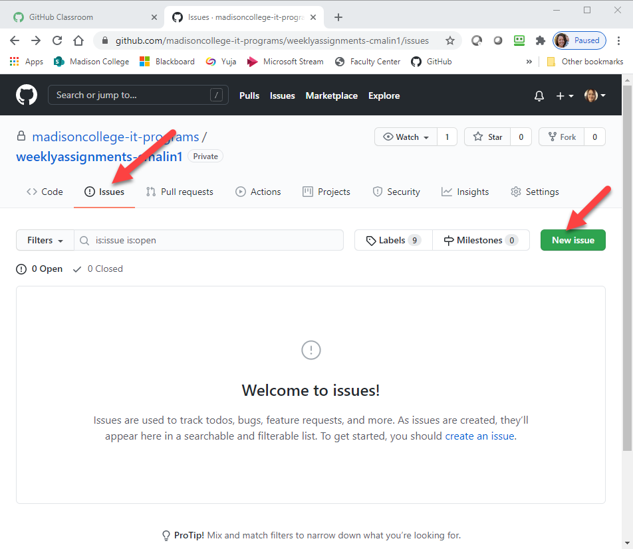

1. Give your issue a meaningful title and include any comments about things you want specific feedback on or questions you may have about the assignment.